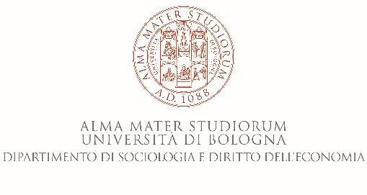

**Department of Sociology and Business Law**

**25 June 2018,** Aula Riunioni (first level)

Via San Giacomo - Bologna

9.00-9.15 – Introduction Prof. Claudia Golino

9.15-11.00 – The General Agreement on Trade in Services (GATS) Modes of Supply and its influence on the operations of Multinational Enterprises (MNEs)”Prof. Hussain Rammal, UTS (Sydney)

**Con il Patrocinio del Comune di Forlì**

**Con il Patrocinio del Comune di Forlì**

**University of Bologna, Italy**

**School of Economics, Management and Statistics**

**and**

**Department of Sociology and Business Law**